1. Title Page
Project Title: Printer Management System using Queue
Student Name: Amarnath B
Register Number: 921724115003
Department: Computer Science Design
College Name: Sethu Institute of Technology
Course: Programming in C
Guide / Trainer Name:Balaji B
Submission Date: 26-02-2026

2. Abstract
The Printer Management System is a menu-driven C program that simulates the working of a real-time printing queue. The system allows users to add print jobs, view pending jobs, print the next job, search for a job, and save/load job data using file handling. The program uses the queue data structure to ensure First-In-First-Out (FIFO) processing of print requests. This project helps in understanding structured programming, arrays, functions, and file operations in C.

3. Introduction
In environments such as offices, colleges, and cyber cafes, multiple users send documents to a shared printer. Managing these print requests efficiently is important to maintain order and avoid conflicts.
This project solves the problem by implementing a queue-based printer management system. It ensures that print jobs are processed in the same order in which they are received.
The system is useful in:
- Computer labs
- Office printer systems
- Network printing environments
- Educational demonstrations of queues

4. Objectives
- To understand structured programming in C
- To implement queue operations
- To use loops and conditional statements
- To work with arrays and functions
- To implement file handling
- To improve logical thinking and problem-solving skills

5. Tools & Technology
- Programming Language: C
- Compiler: GCC / CodeBlocks / Turbo C
- Platform: Windows / Linux

6. System Requirements

Hardware
- Basic computer
- Minimum 4 GB RAM
- Keyboard and monitor

Software
- C Compiler (GCC / Turbo C / CodeBlocks)
- Any IDE or Text Editor

7. Methodology / Algorithm
- Start the program
- Load previous print jobs from file
- Display menu to user
- Read user choice
- Perform selected operation:
  - Add print job
  - View jobs
  - Print next job
  - Search job
  - Save and exit
- Display result
- Repeat until user exits
- End program

8. Flowchart
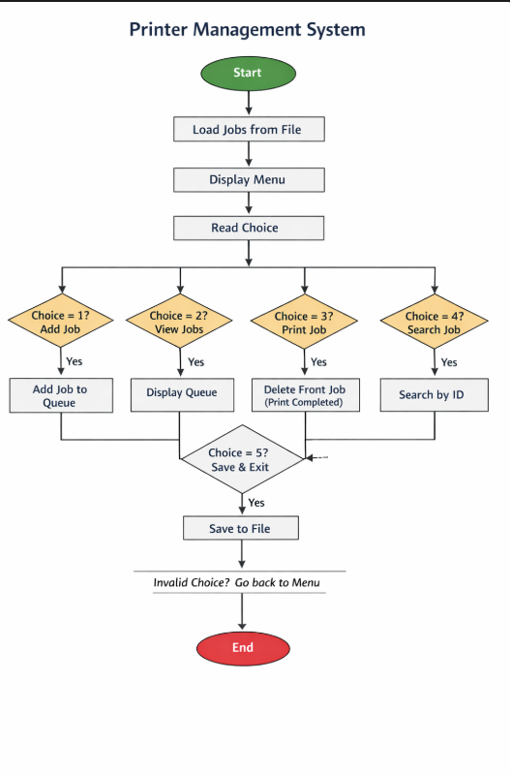

9. Program Code
#include <stdio.h>
#include <stdlib.h>
#include <string.h>
#define MAX 100
struct PrintJob {
int jobID;
char userName[50];
int pages;
};
struct PrintJob queue[MAX];
int front = -1, rear = -1;
void addJob();
void viewJobs();
void deleteJob();
void searchJob();
void saveToFile();
void loadFromFile();
void addJob() {
if (rear == MAX - 1) {
printf("\nQueue Overflow! Cannot add more jobs.\n");
return;
}
struct PrintJob job;
printf("\nEnter Job ID: ");
scanf("%d", &job.jobID);
printf("Enter User Name: ");
scanf("%s", job.userName);
printf("Enter Number of Pages: ");
scanf("%d", &job.pages);
if (front == -1) front = 0;
queue[++rear] = job;
printf("\nPrint Job Added Successfully!\n");
}
void viewJobs() {
if (front == -1 || front > rear) {
printf("\nNo Print Jobs in Queue.\n");
return;
}
printf("\n--- Print Job Queue ---\n");
for (int i = front; i <= rear; i++) {
printf("Job ID: %d | User: %s | Pages: %d\n",
queue[i].jobID,
queue[i].userName,
queue[i].pages);
}
}
void deleteJob() {
if (front == -1 || front > rear) {
printf("\nQueue Underflow! No jobs to delete.\n");
return;
}
printf("\nPrinting Job ID: %d\n", queue[front].jobID);
front++;
printf("Job Completed & Removed from Queue!\n");
}
void searchJob() {
int id, found = 0;
printf("\nEnter Job ID to Search: ");
scanf("%d", &id);
for (int i = front; i <= rear; i++) {
if (queue[i].jobID == id) {
printf("\nJob Found!\n");
printf("User: %s | Pages: %d\n",
queue[i].userName,
queue[i].pages);
found = 1;
break;
}
}
if (!found)
printf("\nJob Not Found!\n");
}
void saveToFile() {
FILE *fp = fopen("printer_data.txt", "w");
if (fp == NULL) {
printf("Error saving file!\n");
return;
}
for (int i = front; i <= rear; i++) {
fprintf(fp, "%d %s %d\n",
queue[i].jobID,
queue[i].userName,
queue[i].pages);
}
fclose(fp);
}
void loadFromFile() {
FILE *fp = fopen("printer_data.txt", "r");
if (fp == NULL) return;
struct PrintJob job;
while (fscanf(fp, "%d %s %d",
&job.jobID,
job.userName,
&job.pages) != EOF) {
if (front == -1) front = 0;
queue[++rear] = job;
}
fclose(fp);
}
int main() {
int choice;
loadFromFile();
while (1) {
printf("\n===== Printer Management System =====\n");
printf("1. Add Print Job\n");
printf("2. View Print Jobs\n");
printf("3. Print Next Job\n");
printf("4. Search Job\n");
printf("5. Save & Exit\n");
printf("Enter choice: ");
scanf("%d", &choice);
switch (choice) {
case 1: addJob(); break;
case 2: viewJobs(); break;
case 3: deleteJob(); break;
case 4: searchJob(); break;
case 5:
saveToFile();
printf("\nData Saved. Exiting...\n");
exit(0);
default:
printf("\nInvalid Choice!\n");
}
}
return 0;
}

10. Sample Input / Output
Sample Run
===== Printer Management System =====
1. Add Print Job
2. View Print Jobs
3. Print Next Job
4. Search Job
5. Save & Exit
Enter choice: 1
Enter Job ID: 101
Enter User Name: Arun
Enter Number of Pages: 5
Print Job Added Successfully!

11. Result
The Printer Management System program was compiled and executed successfully. All queue operations and file handling worked as expected.

12. Applications
- Office printer management
- Computer lab printing systems
- Network print servers
- Educational demonstrations of queues

13. Conclusion
The project successfully demonstrates the implementation of a queue using C programming. It improves understanding of structured programming, file handling, and data management concepts.

14. Future Enhancements
- Implement circular queue
- Add priority printing
- Improve user interface
- Add page cost calculation
- Develop GUI version

15. References
- E. Balagurusamy — Programming in ANSI C
- Online C programming tutorials
- Classroom notes

